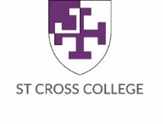

St Cross College Memorabilia Order Form 2022
Please return form to staff member who will process your total payment
development@stx.ox.ac.uk
All prices include VAT where applicable

Item | Total Cost  Per Item | Quantity  Ordered | Item to be Collected Later
Memorabilia
Luggage Tag | £5.00
Silk Tie | £30.00
Tie Slide | £5.00
Silver Pendant Necklace | £25.00
Silver Bracelet Charm Lobster | £15.00
Keyring | £3.50
USB Stick (16Gb) | £5.00
Teddy Bear | £10.00
Travel Mug | £5.00
St Cross Bookmark | £1.00
St Cross Blanket | £15.00
Lapel Pin | £1
Bookmarks | £1
Books & Prints
St Cross Book Bundle | £15.00
St Cross Cookbook | £5.00
‘St Cross College at Fifty’ Volume (paperback) | £5.00
‘St Cross College at Fifty’ Volume (hardback) | £7.50
‘Four Corners’ Poetry Anthology | £2.50
‘Blackman Collection  of Watercolours’ Guide | £5.00
St Cross Watercolour | £3.50
Old School House Print | £4.00
Library Sale Books
Total Payable

Name: (BLOCK CAPITALS)………………………..………. Signature: ……………………………................
Student Number: ……………………………………….... Email/: …………………..…………..……………
Please charge my Battels account
Paid by card on the day
v. 25.05.22

